19.1.5 Editors - NLA Editor - Edit Menu
NLA Editor - Edit Menu 2
Transform 2
Grab/Move 2
Extend 2
Scale 2
Snap 2
Duplicate 2
Linked Duplicate 3
Split Strips 3
Delete Strips 3
Delete Tracks 3
Apply Scale 3
Clear Scale 3
Sync Action Length 3
Make Single User 3
Swap Strips 3
Move strips up 3
Move Strips down 4
Track Ordering 4
Remove Empty Animation Data 4
Start Tweaking Strip Actions 4
Start Editing Stashed Actions 4

NLA Editor - Edit Menu
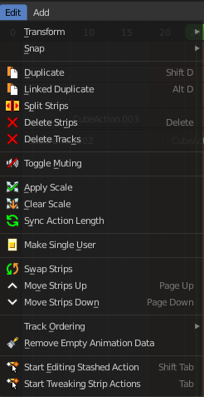
This menu contains functionality to manage the keyframes.

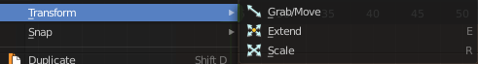
Transform

Grab/Move
Moves the selected keyframe(s).

Extend
Moves the last keyframes of the selection.

Scale
Scales the selected keyframes. You need to have more than one keyframe selected.

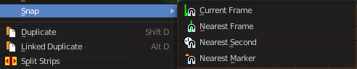
Snap
Snaps the selected keyframes by the chosen method.

Duplicate
Duplicate selected keyframes.

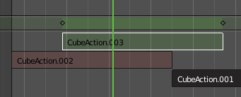
Linked Duplicate
Duplicates the selected strip(s), and creates a new track for the duplicates. This copy is linked to the original action strip. Modifications at the original will also affect the linked action strip.
Linked strips are visually different from normal strips. And when you start to modify the linked duplicate, then the original strip will turn red.

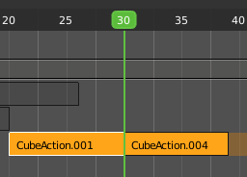
Split Strips
Splits the selected strip(s) at the marker position.

Delete Strips
Deletes the selected strips.

Delete Tracks
Deletes the selected track(s).
Toggle Muting
Disables the selected action clip. Be careful, there is no visual hint if the clip is muted or not.

Apply Scale
Applies the current scale of the clips to be 1.

Clear Scale
Resets the scale of the clip back to 1.

Sync Action Length
Synchronize the length of the action with the keyframe length used in the strip.

Make Single User
You can create linked duplicates. Make single user makes them into individual clips.

Swap Strips
Swaps the selected strips.

Move strips up
Moves the selected action strips upwards into the next track.

Move Strips down
Moves the selected action strips downwards into the next track.

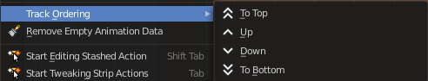
Track Ordering
Order the tracks.

Remove Empty Animation Data
Removes action clips that are empty.

Start Tweaking Strip Actions
Allows you to edit the keyframe data within the Action strip. The strip will turn gree, and in the Dope Sheet editor you will find the keyframes again, which you can tweak now.
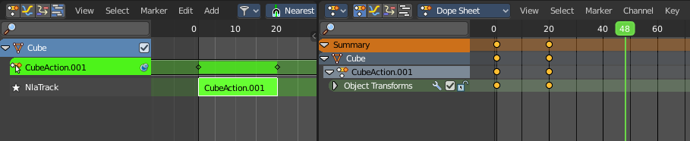

Start Editing Stashed Actions
Same as Start Tweaking Strip Actions. But with Solo already ticked. Which allows editing of the animation data for this strip only.
